4/26/2021

Nadir Hussain

023-18-0025

Data Science

Lab 06

Data Science/ Python for data Analysis.

Libraries used

1. Numpy
2. Scipy
3. Pandas
4. Matplotlib
5. Seaborn
6. Scikit learn
7. Statsmodels.formula.api

Why to use

1. Numpy: Numerical python library, contains multi dimensional array and matrix data structures. Used to perform mathematical operations on arrays and matrices like arithmetic, algebraic, statistical and trigonometric.
2. Scipy: Used for mathematical , engineering and technical problems. Provides commands to visualize the data.
3. Pandas: Most widely used for machine learning, data science tasks. Built on top of Numpy. It works similar to Excel. Provides tabular data visualization. Can be used to create 1d homogeneous arrays called Series, 2d labeled heterogeneous arrays called DataFrame.
4. Matplotlib: Used to work with large data sets by visualization.
5. Seaborn: Built on matplotlib, provides attractive visualization and graphical interaction

Import all of above libraris

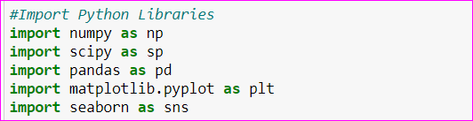

Working with Pandas—Series

Numpy functions

Creating arrays

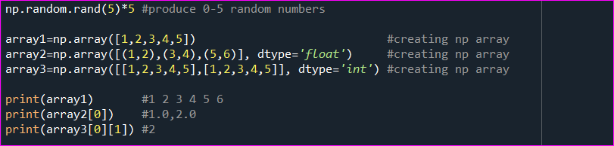

We can add, subtract, multiply and divide arrays of same dimension

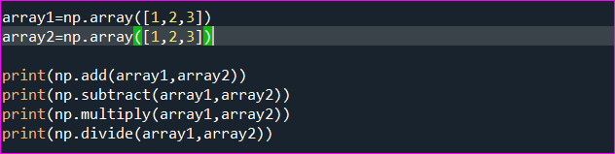

Finding transpose of array

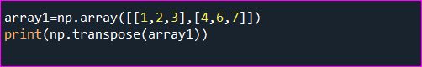

Basic statistics on array

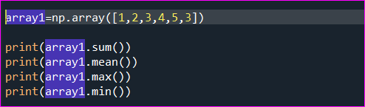

Standard deviation of data

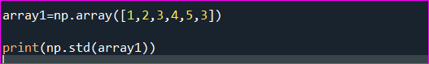

Pandas Functions

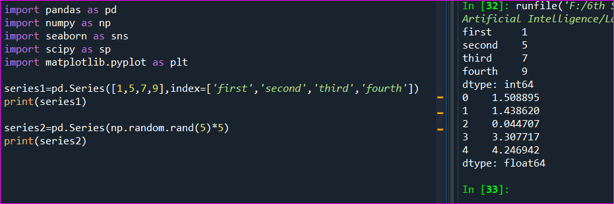

Creating Series from array and dictionary

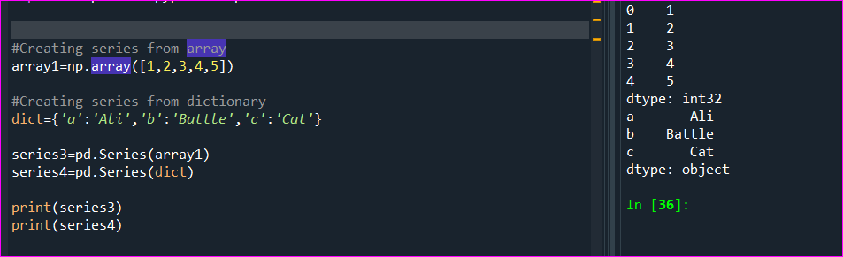

Slicing Series elements

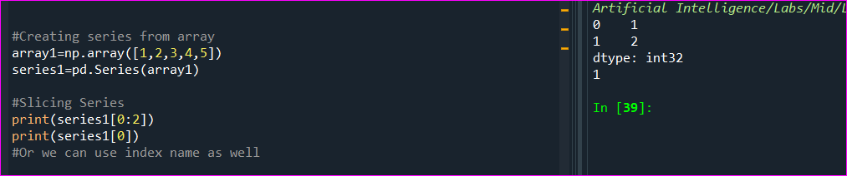

Head and median functions of pandas series

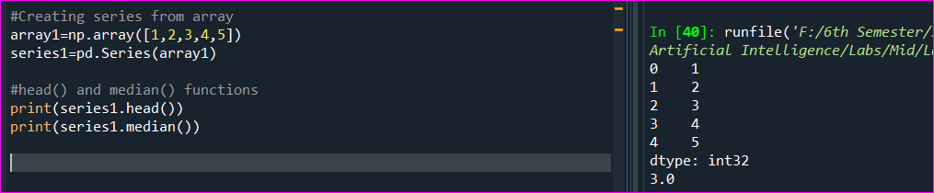

Creating series from range function

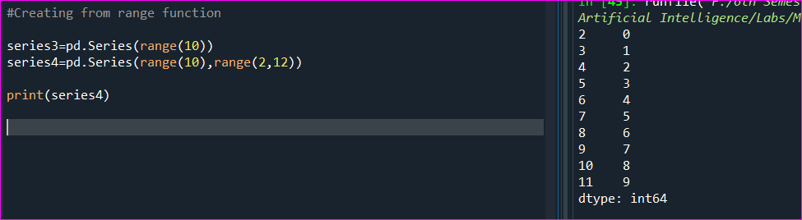

empty property or object of Series

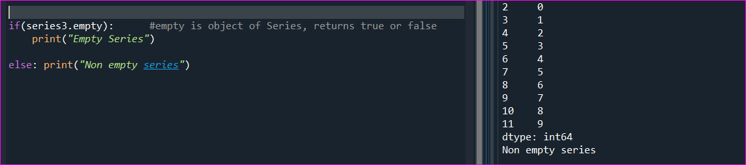

Pandas Data Frame

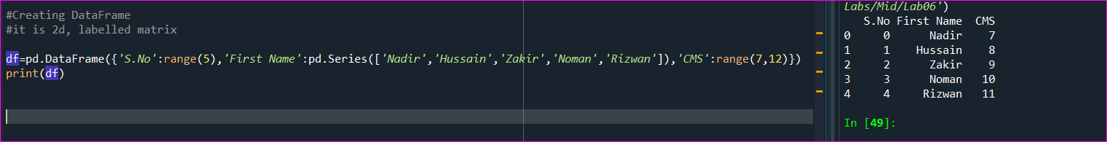

Adding new column to dataframe



Reading and analyzing CSV dataset in pandas

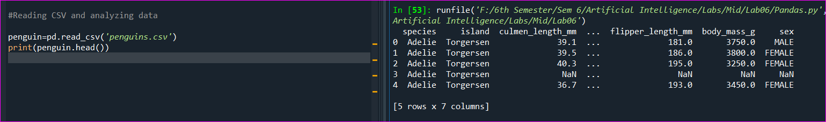

Reading from head and tail of dataset

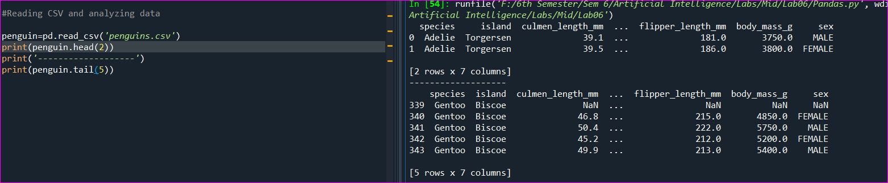

Get names of columns of dataset



Get number of records in dataset

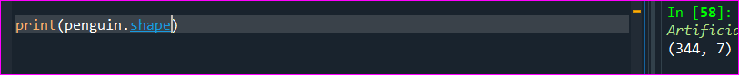

344 rows with 7 columns

Get mean, deviation or all

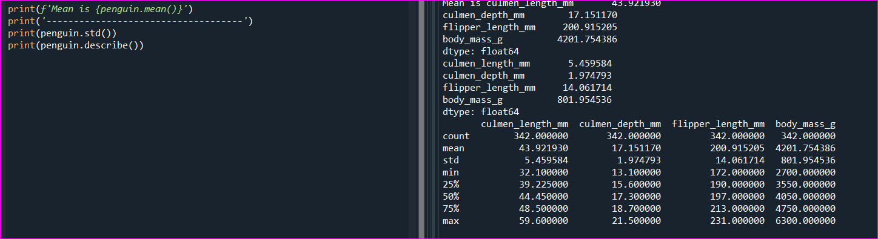

Count records and group by column

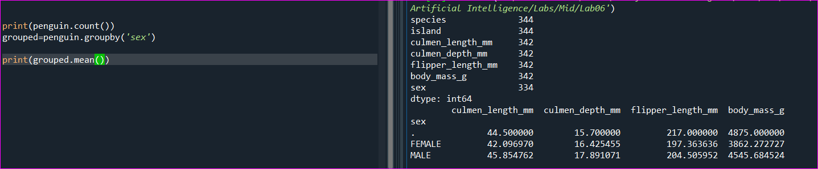

Group by and calculate mean of particular column

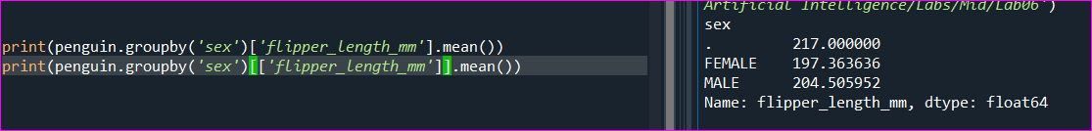

If sex is female, select 5 penguins

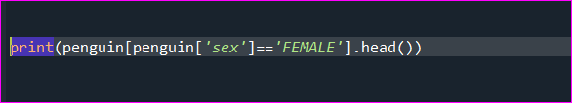

SELECT 10 to 12 records with 3 columns

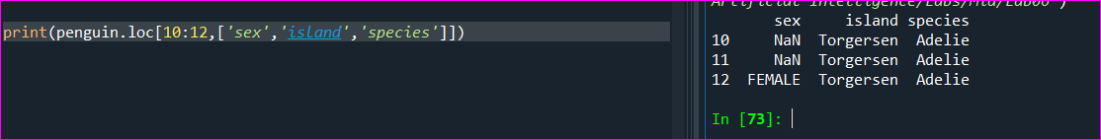

Sort penguins with body_mass_g

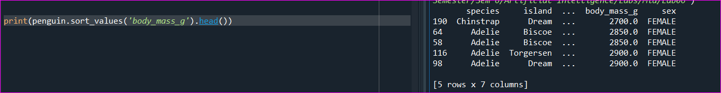

Select rows that have atleast one missing value 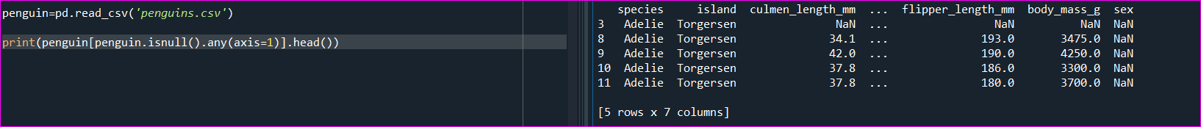

Select all rows where ‘sex’ column value is missing

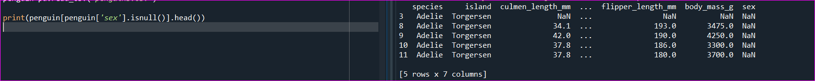

Remove all rows with any missing value

